Task on Jenkins-01
- Install Jenkins and run Jenkins on port number 8081.
Connected to ec2
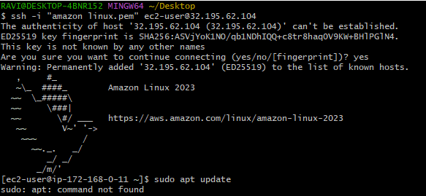
Installed java with the below command in the image:
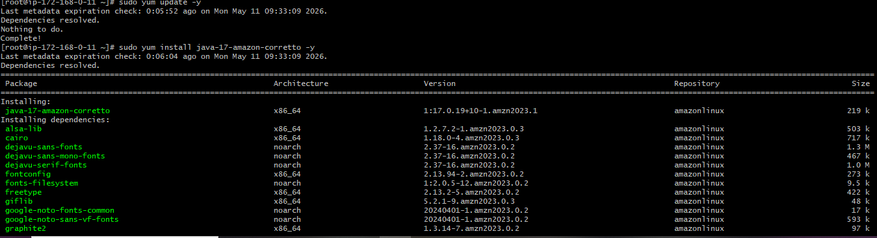
Installed Jenkins with following commands:
sudo wget -O /etc/yum.repos.d/jenkins.repo \
https://pkg.jenkins.io/rpm-stable/jenkins.repo
sudo dnf install java-21-amazon-corretto -y
sudo rpm --import https://pkg.jenkins.io/redhat-stable/jenkins.io-2023.key
sudo yum install jenkins -y
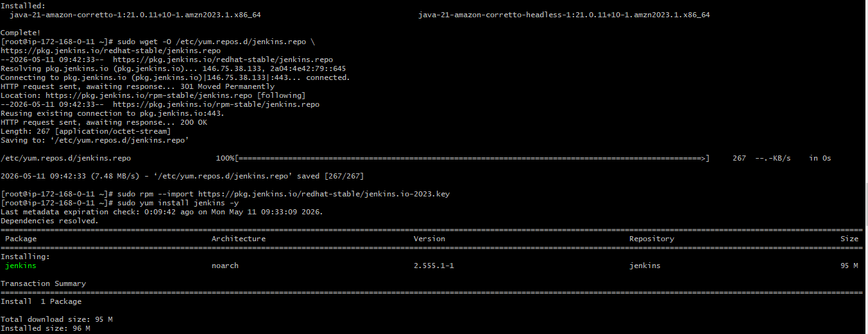
Jenkins is up and running:
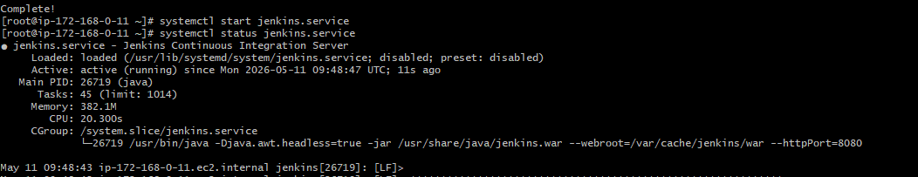
Changed the port number from 8080 to 8081 in the below path: sudo vi /usr/lib/systemd/system/jenkins.service
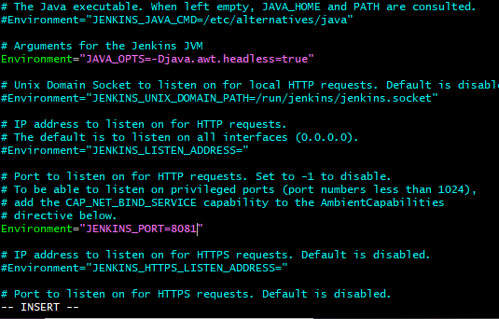
Jenkins running on port 8081:
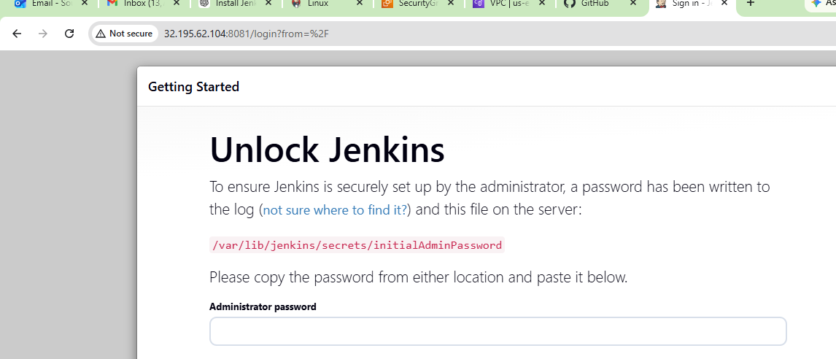
- Secure Jenkins server
Logged in with the below path in the file for the password:
cat /var/lib/jenkins/secrets/initialAdminPassword
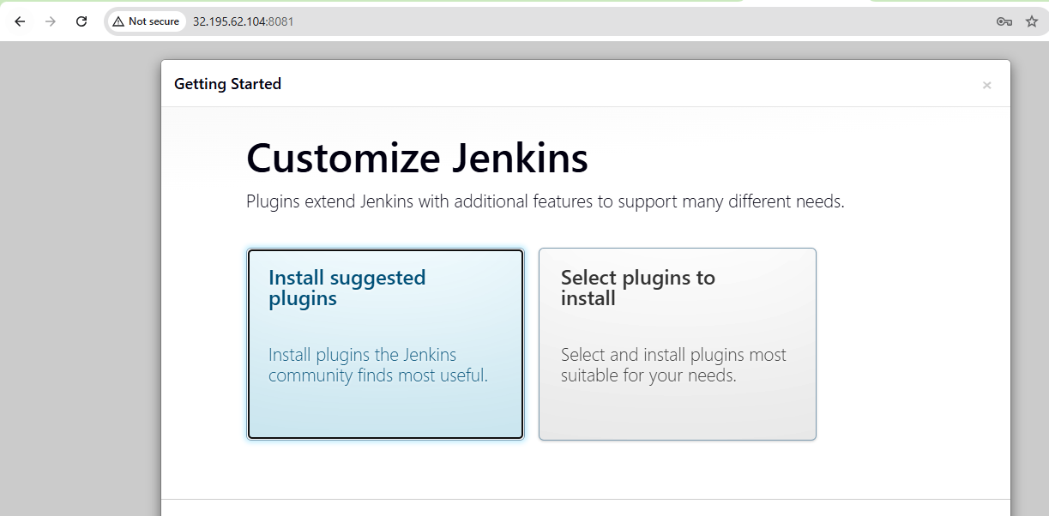
Installed the basic packages as shown in the video:
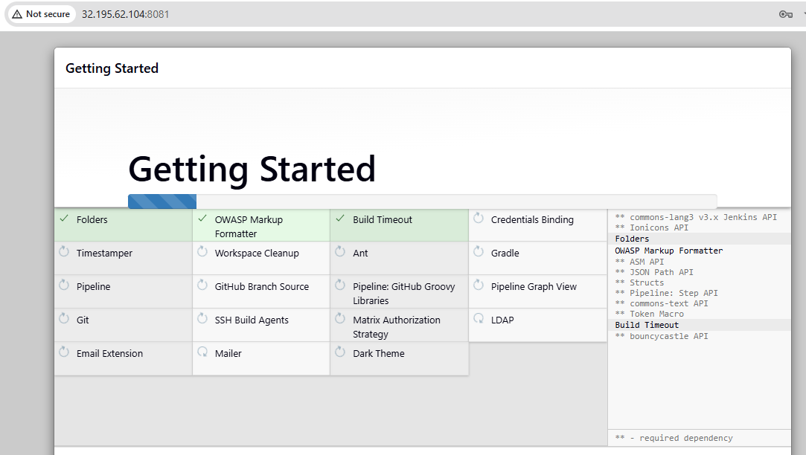
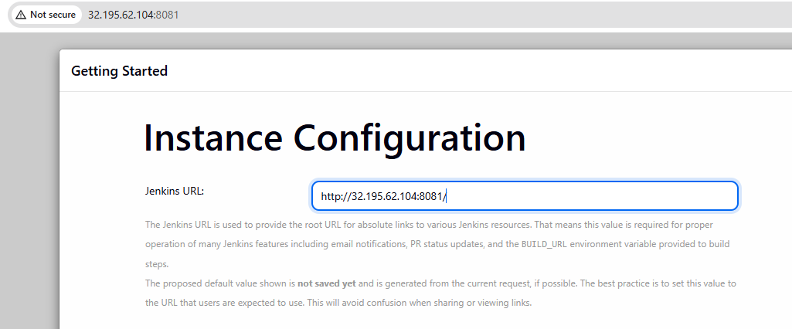
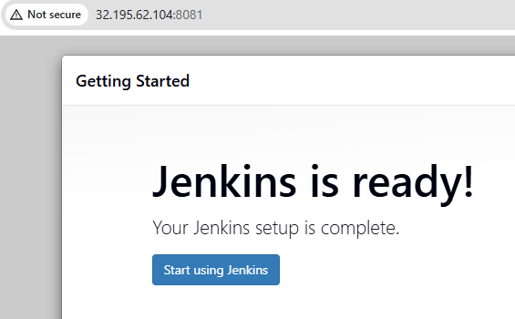
Proudly welcome by Jenkins:
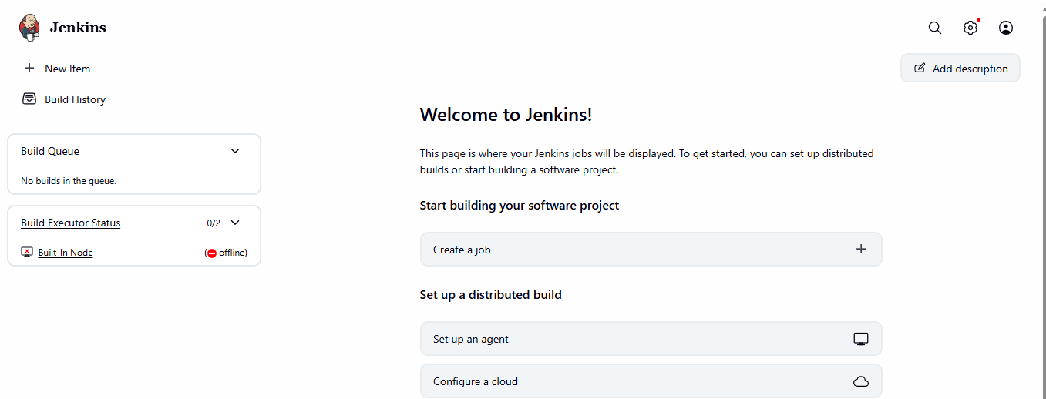
Plugged in with a new role as shown below under plugins:
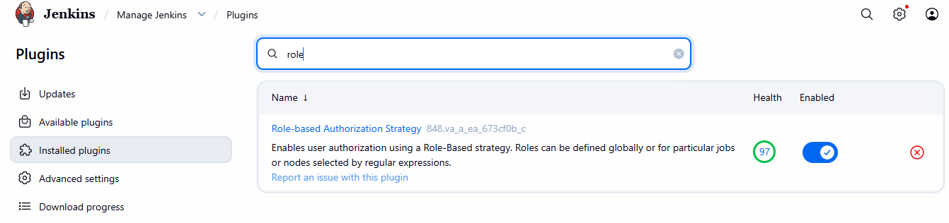
- Create users called DevOps, Testing in Jenkins with Limited access.
Created a user with name as Devops:
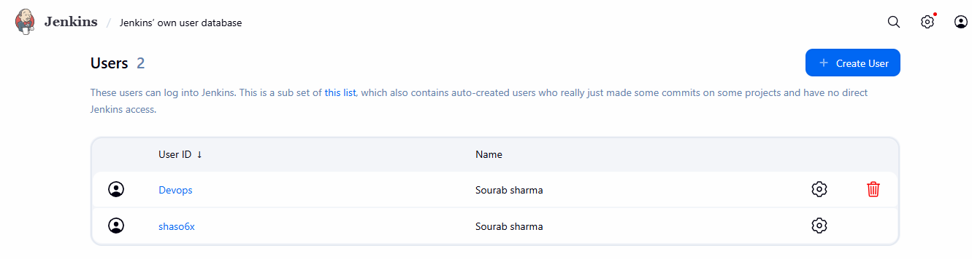
Created a new role with limited access to 3 different users:
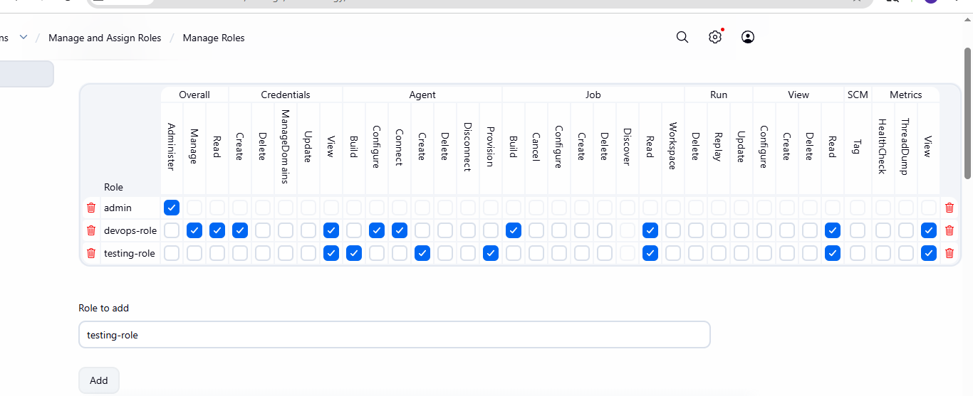
Then assign the roles to the users:
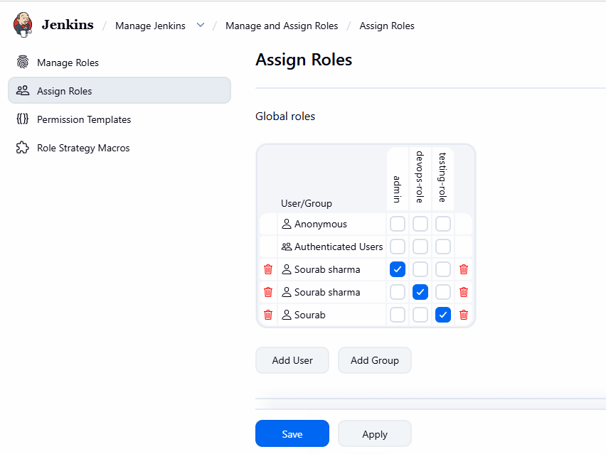
- Configure labels and restrict the jobs to execute based on label only.
Created a new job as shown in the below image:
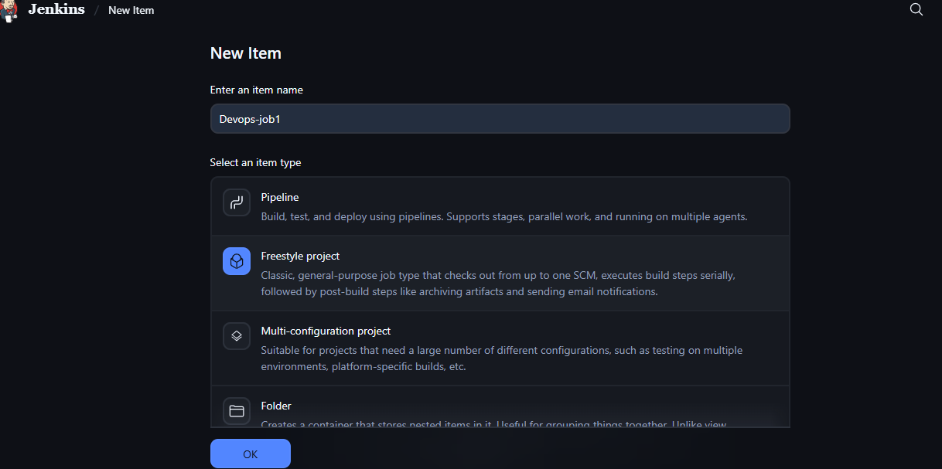
Selected the new expression with Dev:
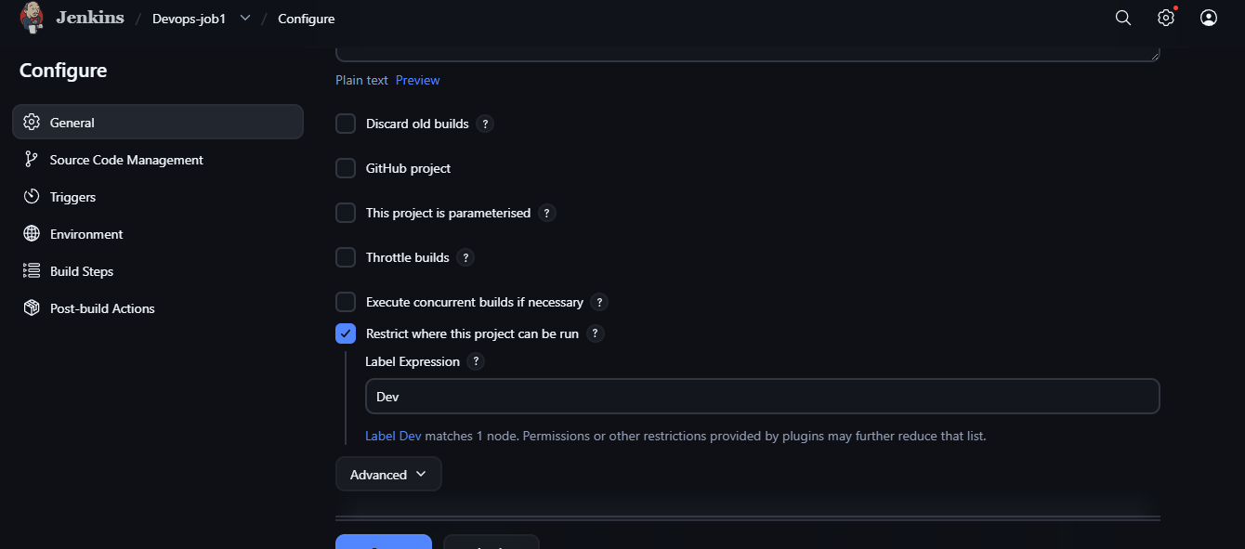
Click on build step and enter the content:
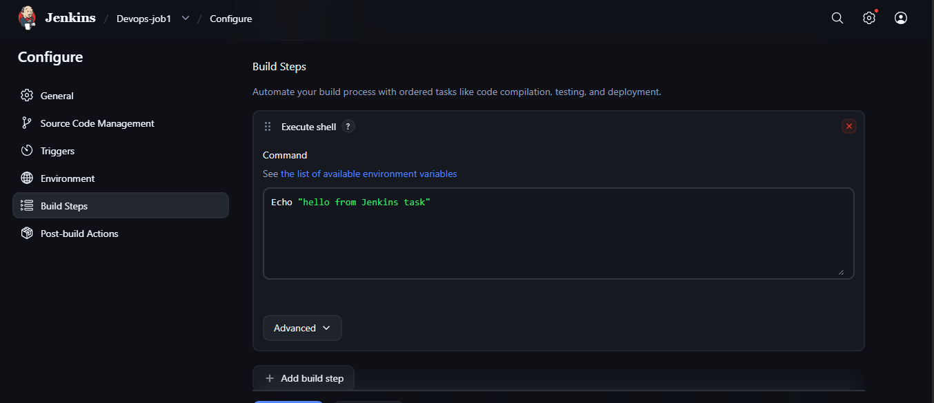
Mistake done in the description with capital letter in the start which is the reason 2 task failed and after that made the changes correct and then the task executed successfully:
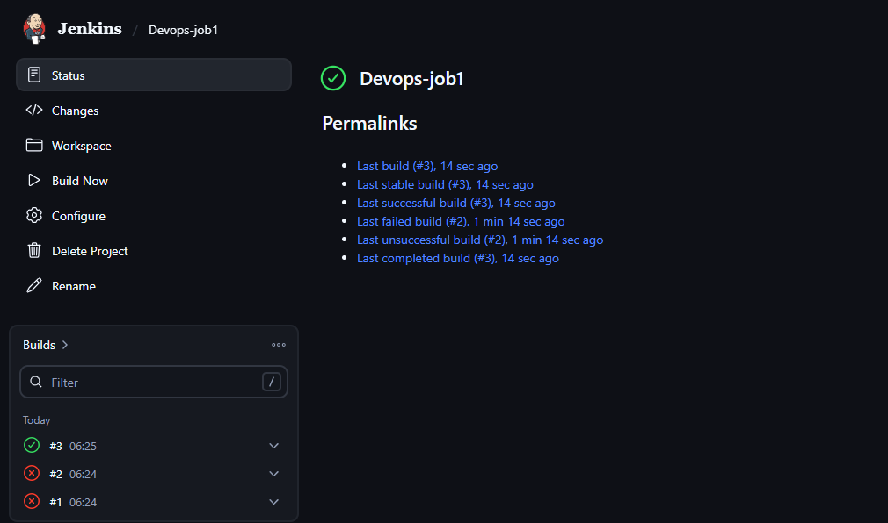
Click the task drop down and then check with console output and then the result will be shown as below:
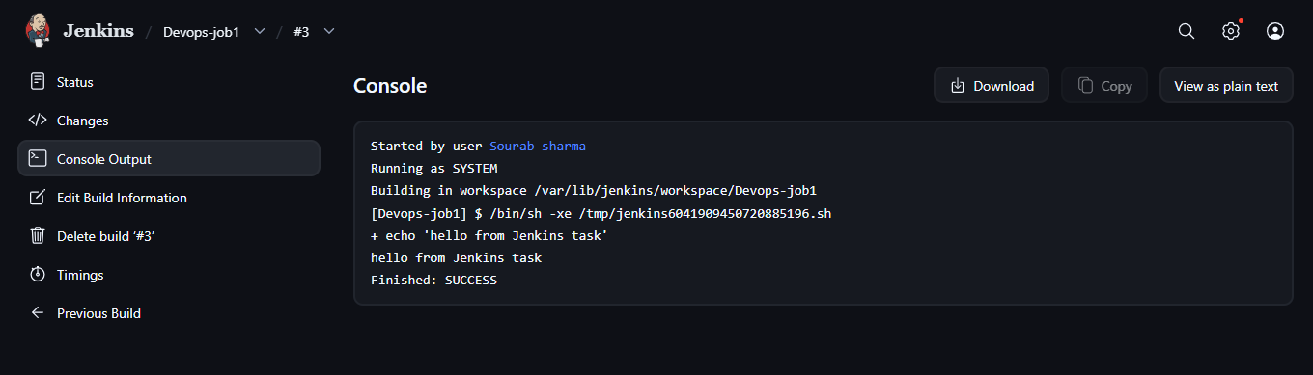
- Create Three sample jobs using the below URL.
  - Source Code: https://github.com/betawins/Techie_horizon_Login_app.git
Connected to the instance and installed git in it: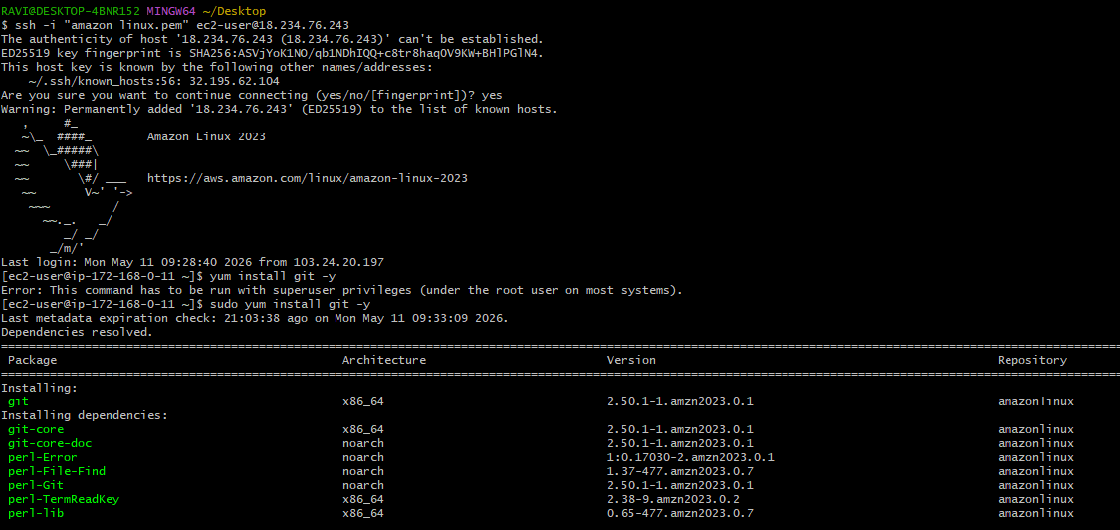
Created a new job {sample-job-01} as shown above in the previous task and then added the Git-repo link provided above and then applied the changes and then click on build-now and then the execute steps which is console output is shown below:
Sample-job-01
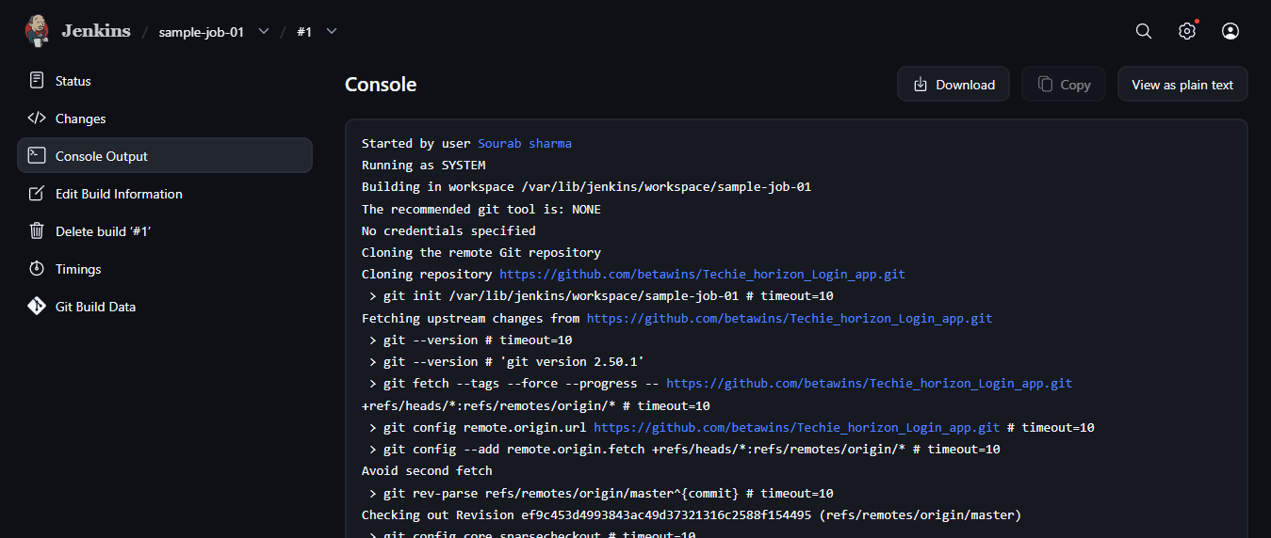
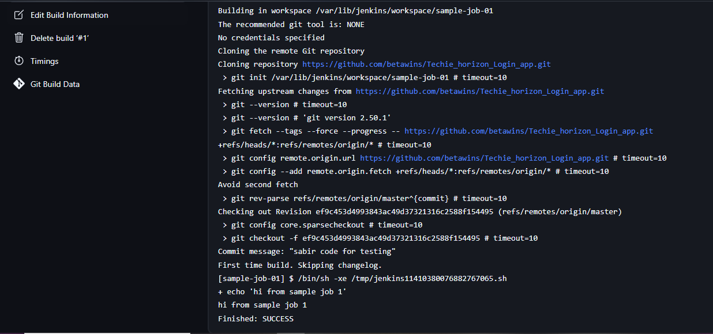
Created a new job {sample-job-02} as shown above in the previous task and then added the Git-repo link provided above and then applied the changes and then click on build-now and then the execute steps which is console output is shown below:
Sample-job-2
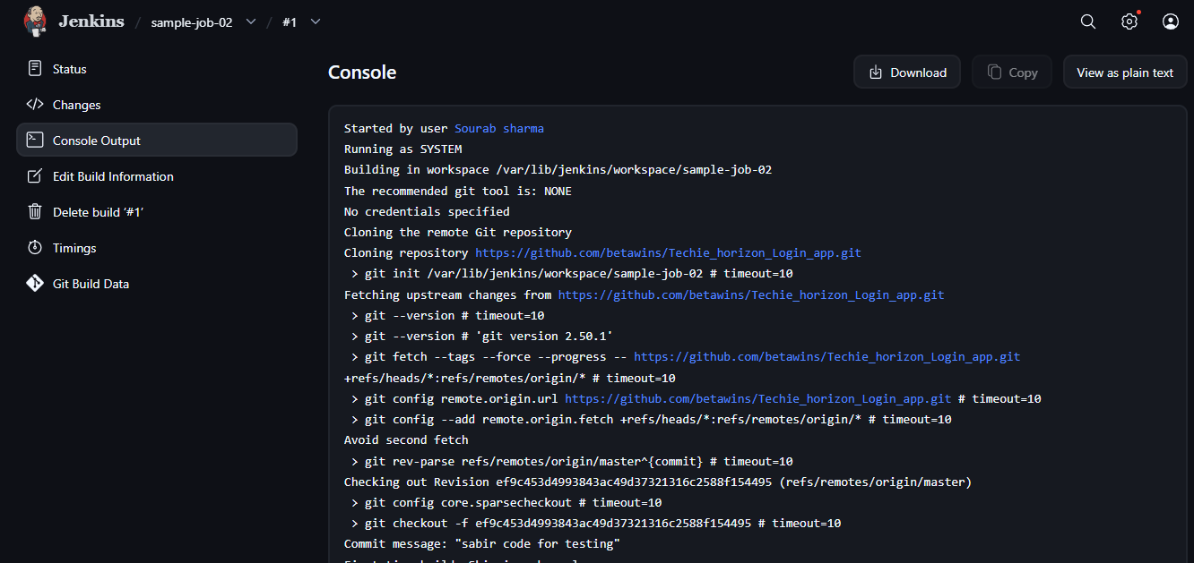
Created a new job {sample-job-03} as shown above in the previous task and then added the Git-repo link provided above and then applied the changes and then click on build-now and then the execute steps which is console output is shown below:
Sample job -03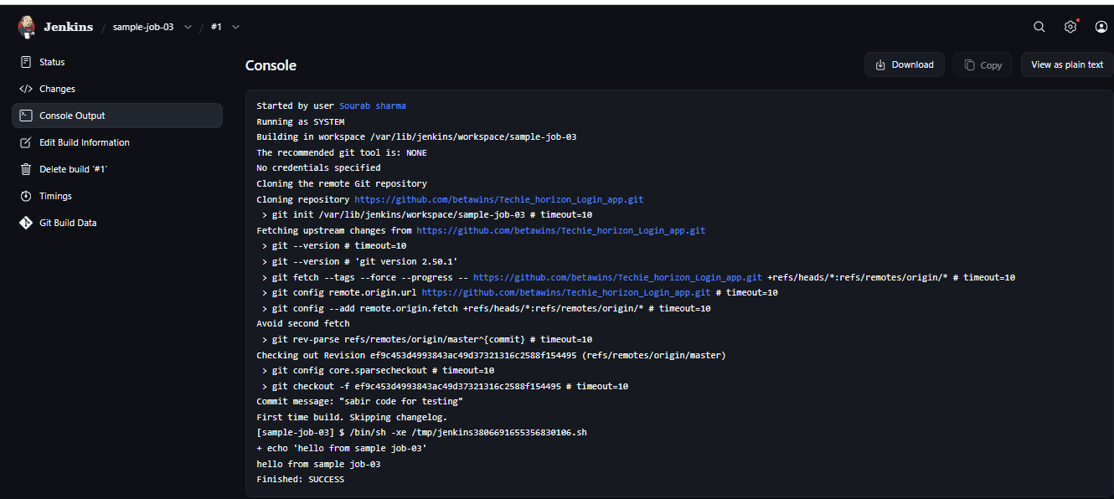 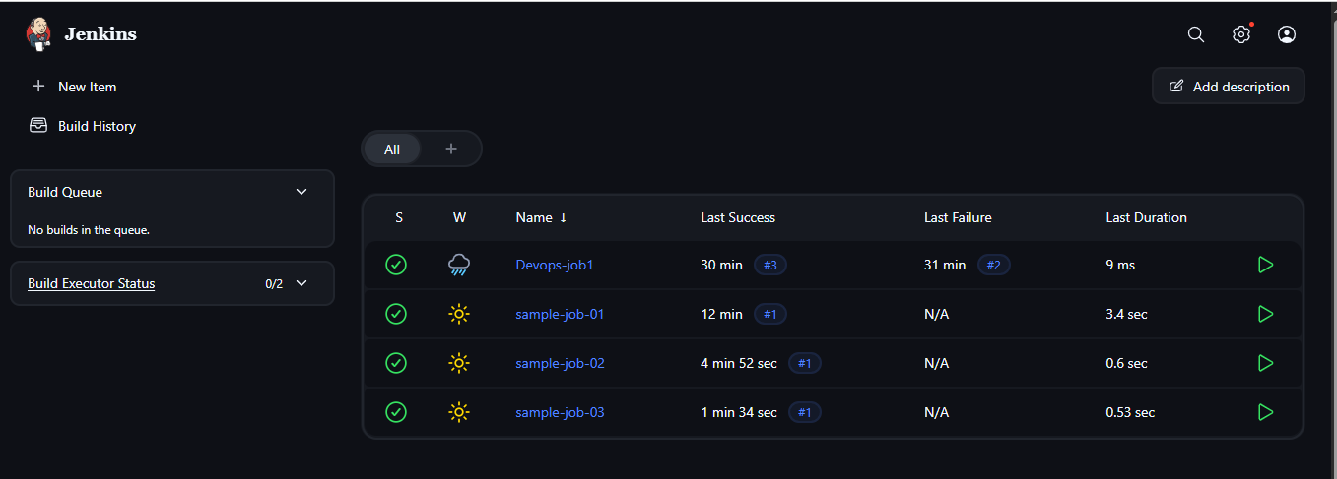
- Create one Jenkins job using GitHub Private repository.
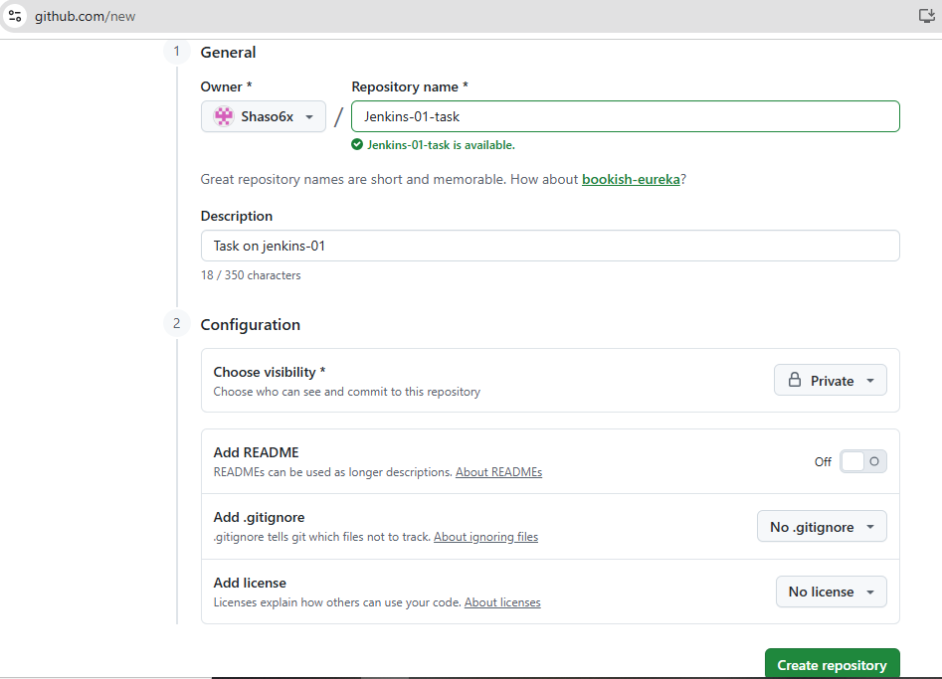
Click on setting and then find Developers setting and then click on token option and then generate:
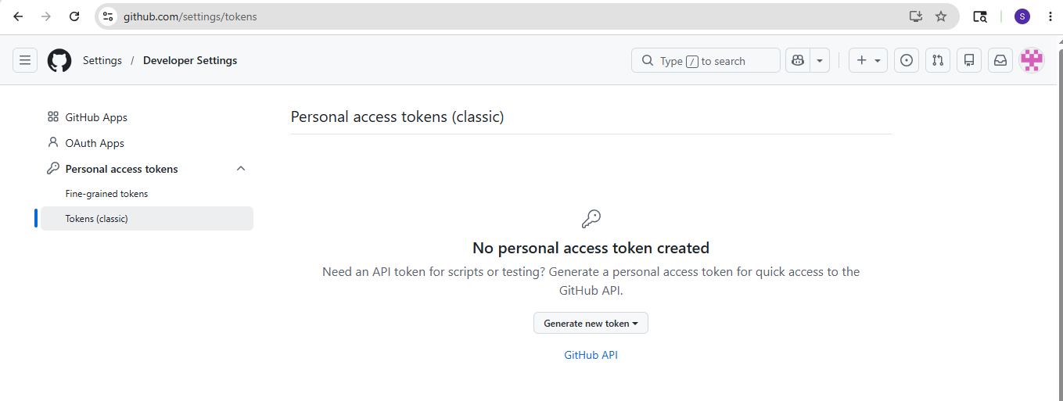
Generated the token: 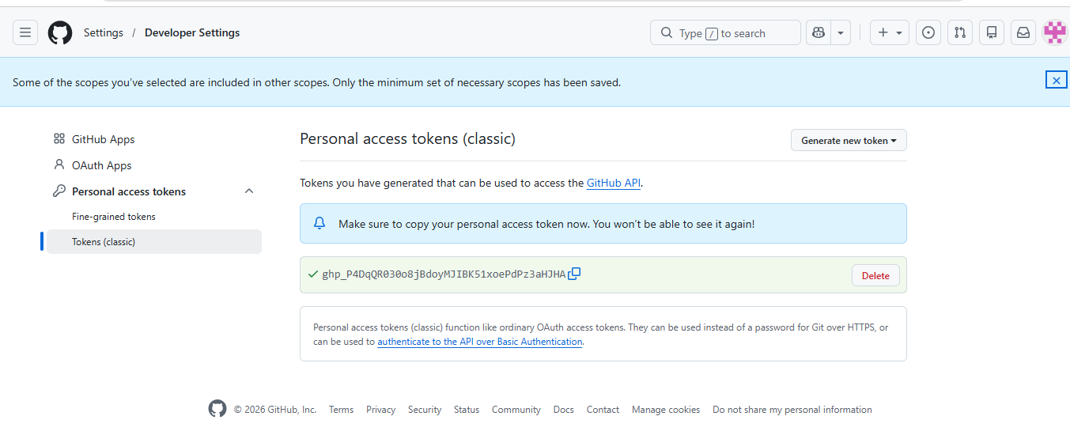
Came to Jenkins manage and then click on credentials and then add global option and then provide the required details as shown below:
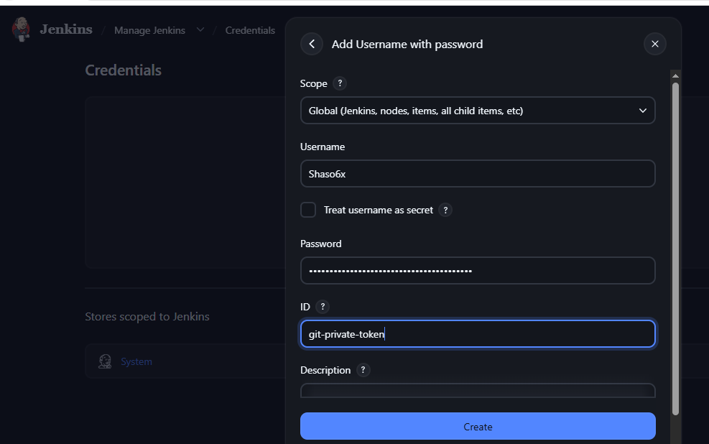
Done with generating the key and added it in Jenkins:
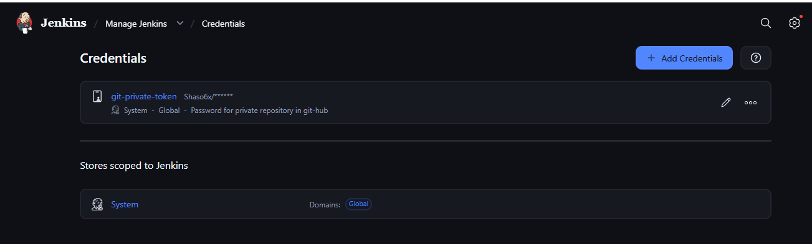
Added new private repository link here and then provided the password dropdown option which was saved above:
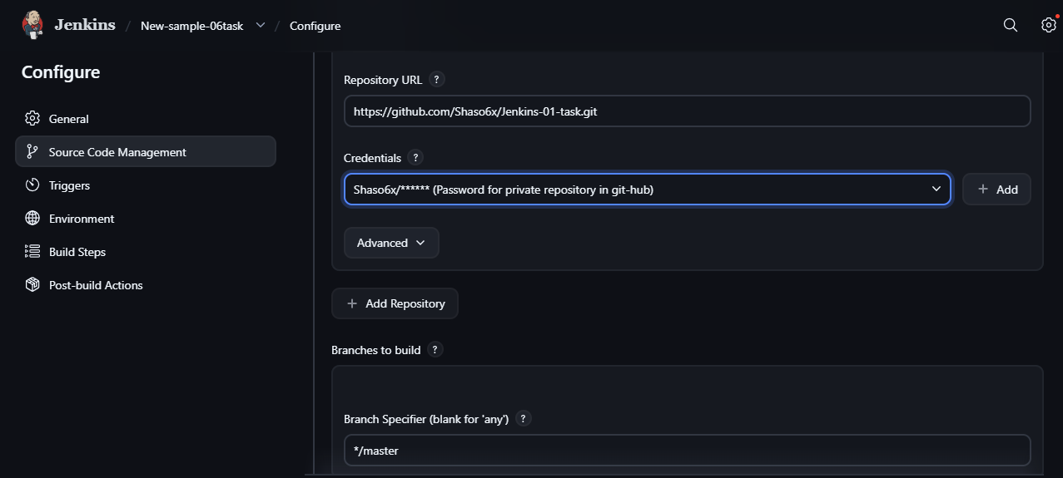
Added the main branch in the above configure option and then click on build now option and then check with the console output and then you will be able to see the result:
